Lab 8 manual: $\frac{e}{m}$ measurement (Tracker)
Dr. D. Beznosko
7/17/2026
For PHYS 1112L only
(Lab outcomes: particle deviation in magnetic field, using Tracker for radius measurements.)

Abstract
The objective of this laboratory is to measure the charge to mass ratio of an electron. The video of the experiment is used for this purpose. The result is compared with the accepted value within errors.

Introduction
The first person to measure a charge to mass ratio for the electrons in 1897 was J. J. Thomson for what was called at the time ‘cathode rays’. The existence of this ratio later convinced him that these rays were in fact particles, with a negative change. Now we call them electrons. Remember to reference historic information as well! What do we use electrons for today? Can we use them to power up cars?

Experimental Setup
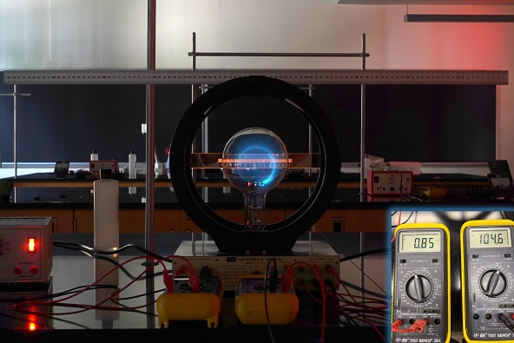
Shown in Figure 1, the experimental setup that consists of the ruler, two multimeters, e/m apparatus, and power supplies. Provide DETAILED description of PASCO [1] e/m apparatus!
e/m apparatus
Ruler
Multimeters
Multimeters insert
Power supply
Figure 1: The experimental setup schematic. An insert in the right lower corner shows the top view on both multimeters.

Procedure
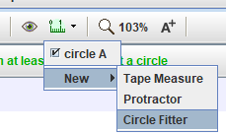
You can use the individual photos provided or the video that combines all five photos as individual frames for convenience (recommended). For the frame/photo 1, set the scale by using a ruler and use the Circle Finder tool to measure the radius of the circle that is drawn by a bright blue filament in the bulb. Choose the approximate center of the filament, when possible, but stay towards the inner radius, ignore the outside glowing halo. Holding shift, choose three points around the circle (see video tutorial if needed at https://youtu.be/IrD10scYpsA?t=2932) and record the radius. Do this at least 5 times by deleting the circle and adding it back. Find average of the radius and the stdev – this is your statistical error. Keep the last circle fitter result and delete and add the ruler 5 times – the stdev of the radius will be the systematic error. Combine in quadrature. You can use the same systematic error for all 5 frames/photos. Record the current and accelerating voltage from the multimeters, and their errors (use precision as systematic. Find it in the multimeter manual. Show details for finding all errors for at least 1 frame!).
Measure radius and record the voltage from the remaining four frames/photos. With errors!

Experimental Data
The results of the measurements should be organized as Table 1 or similar. Think about how to organize this table. The error can be listed in a different column or as value ± error unit. Don’t include all data values here, only relevant means, stdev etc. In most cases, individual data points are not needed, especially for computer-based labs. What is the voltage error?
Table 1: Experimental data.
Accelerating Voltage, V | Radius, m | Current, A

Provide description about each entry as needed, don’t just leave the table without text in this section. Organize well so that data takes up less space, but everything needed is included.

Theory
As a charged particle enters the magnetic field directed perpendicularly to the velocity of the particle, it starts to rotate with a radius of orbit
$$r=\frac{mv}{qB}\left(1\right)$$
where $m$ is the mass of the particle, $v$ is the speed of the particle, $q$ is the magnitude of the particle's charge, and $B$ is the strength of the magnetic field. For an electron, the equation 1 becomes
$$r=\frac{m_{e}v}{eB}\left(2\right)$$
where $e$ is the magnitude of the charge of an electron and $m_{e}$ is electron’s mass.
The magnetic field produced near the axis of a pair of Helmholtz coils is given by the equation:
$$B={\left(\frac{4}{5}\right)}^{\frac{3}{2}}\frac{Nμ_{0}I}{a}\left(3\right)$$
where $N$ is the number of turns on each Helmholtz coil ($N=130$ in our case), $μ_{0}$ is the magnetic permeability of free space, and $a$ is the radius of the Helmholtz coils ($a=150mm$).
After the electrons are accelerated through the accelerating potential difference V, gaining kinetic energy, their speed becomes:
$$v=\sqrt{\frac{2eV}{m_{e}}}\left(4\right)$$
Combining equations (2), (3), and (4) produces the final formula for e/m ratio:
$$\frac{e}{m_{e}}={\left(\frac{5}{4}\right)}^{3}\frac{2Va^{2}}{{\left(Nμ_{0}Ir\right)}^{2}}\left(5\right)$$
Show a derivation of equation 5, filling in missing steps like Lorentz force.
Clearly state what you are going to plot on x and on y axes – think about this, you want the slope to be e/m ratio, so look at eq. 5! Propagate the error for y-values and x-values, show equations and details!
Bonus points: show derivation for equation 3!

Analysis
First, show what are you going to plot – you want you slope to equal to $e/m$, the value that you seek. For other values, check out https://cdn.pasco.com/product_document/012-14265C.pdf or google for the PASCO e over m apparatus and read the documentation. While the manual gives N and a (for the manual, a=R), they don’t give errors. Assume some error for N and a – what do you think is the error for these values? The average radius a is the center of the coils, what is the reasonable error to assume? For N, may be $±1$ turn? Or just use it as perfect? You may use $μ_{0}$ as perfect – check out the error on the known value, its tiny compared to other error contributions in our experiment. Plot the values that you found, find the slope that is the e/m ratio, slope error is the error of the ratio here. Compare your result with the accepted value within the errors.
Note that sources of error can be some issues with the apparatus – do you see any obvious issues?

Conclusion
Comment on your result and the methods used to find it. What did you learn in performing this measurement? Where else can it be used? Can this experiment be improved?

References

[1] | PASCO Scientific, 10101 Foothills Boulevard, Roseville, California 95747 USA.

For the video, an older setup was used with $a=150mm$

